TASK 35 : RUN AN APPLICATION ON JENKINS SLAVE IN SCRIPTED PIPELINE • Activity: • Execute the spring pet clinic application in a Jenkins slave through scripted pipeline • Steps: • Go to the configuration of ScriptedPetClinic job • Modify the scripted pipeline from node { -> node ('slave1') { • Definition of Done: • Upload the screenshot of Jenkins dashboard -> console output of the project to the GitHub under the folder Task34

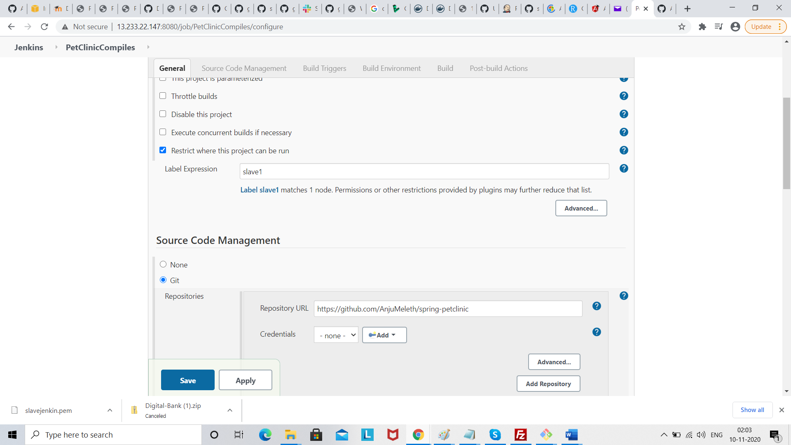

Save

And build

